Oregon Dog Rescue
Behavior References for Foster Support
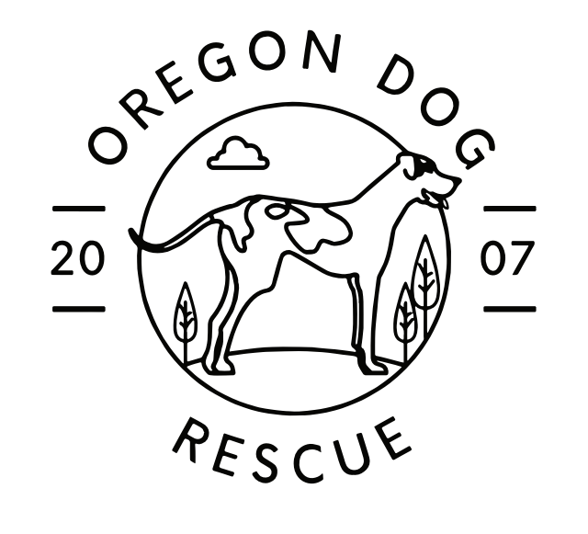

Produced By: Ariel Dobson KPA-CPT, FDM
January 2024

Managing Common Behavior Concerns

Most dog behaviors, especially the ones humans find obnoxious, are natural behaviors for dogs. However, some of these behaviors make it more difficult or dangerous for them to coexist in our human world. Managing these behaviors is important, especially in the foster environment to make them more adoptable.

All of the behaviors in this document can be worked on with training and you may seek further education on the topics if you wish to help improve these behaviors for our dogs but, it must be done in a safe and controlled manner. This document will provide references for further education on behavioral modification if that is something you wish to pursue. For the purposes of foster care all we ask is that the behaviors be managed for your own well being as well as our dogs. The more a behavior is practiced the harder it is to modify in the future, so prevention of behavior rehearsal is very important.

Reactivity
The leash is a necessary safety measure, especially for our rescue dogs with an unknown history. Oregon Dog Rescue foster dogs should never be off leash outside of a secured yard.

Leash reactivity is becoming increasingly common in our fast paced world. Being leashed is completely different than having freedom of movement off leash. Repeatedly exposing a dog to their triggers to the point of reactivity can worsen the issue. For dogs with leash reactivity it is recommended that triggers are avoided on walks. This may mean driving the dog to a less crowded location, choosing off times to walk when fewer dogs or people are out, or not walking them at all. Large parking lots or open fields with good visibility are great locations for reactive dogs.

If you choose to not walk your foster, they will require other enrichment to exercise their body and mind or they may display other unwanted behaviors out of boredom. There will be enrichment suggestions in the reference section.

It is a natural response for a handler to choke up on the leash when they see a trigger to gain the perception of better control. A dog will often feel this pressure and it can trigger an unintended reaction. If possible, keep the leash loose and lure the dog away in the opposite direction to get distance from their trigger. If necessary, you can drag the dog away to avoid a larger reaction or contact with the trigger. Figure out what distance your particular foster can handle when passing another dog and try to never push that distance to the point of causing a reaction.

It is important that we increase the ratio of positive to negative experiences with their triggers. Ideas that can help some dogs when their trigger is unavoidable in a situation are:

- Scatter treats in the grass to get them sniffing and distracted
- Ask them to balance on a bench, stump, or another stable object. Sometimes balancing on something can require enough focus that the trigger can pass by unnoticed
- In neighborhoods, utilize parked cars and other barriers along the sidewalk to block the view of a trigger

Important | If a significant reaction does occur, go home immediately; The rest of the walk is not likely to go well when they have been filled with stress hormones. Allow the dogs to sniff as much as possible especially after a reaction, sniffing is a calming behavior and also burns a whole lot of calories.

Leash Pulling
Leash pulling is an unwanted behavior because it puts stress on the dogs, can leave the handler unbalanced in dangerous situations, and will continue to get worse over time if not managed. Dogs will continue pulling on their leash on walks as long as it works. If a dog pulls forward or towards something they are interested in and we move with them, pulling is being reinforced.

Teaching a dog to not pull while on leash will take repetition and consistency. It is best done on shorter walks with no destination. Most neighborhood walks do not meet our dogs exercise needs anyway, so taking a few days of multiple shorter walks to improve leash manners is ok. Dogs that pull, want to keep moving forward, toward a smell or something of interest.

Important | Do not move with a dog that is pulling, plant your feet and do not move forward until there is slack in the leash.

When there is slack we can reward this by continuing forward, they will likely go back to pulling as it will take time for this behavior to extinguish but stay firm that you will not move until they take a step or two back. They can be praised and offered a treat at your side when they choose to add slack.

People often get discouraged as the process takes time, and in order for the dog to stop pulling, it has to stop working for them all-together. You can reinforce a dog with treats any time they choose to look at you, an “automatic check-in”, and anytime they happen to be at your side. This will build a “reinforcement history” at your side. The ultimate goal does not need to be a perfect heel, but that they put slack back in the line on their own if they feel the leash tightening and that they spend more time defaulting to walking at your side.

Resource Guarding
Although unsettling, and at times unsafe, resource guarding is a natural behavior for dogs. This behavior can be worked on with training but, due to safety, management is a better option for fosters. The best thing we can do is to not give them a reason to guard anything. Our dogs do not have much control over their lives so when they get a hold of something that they like, they really do not want to give it up. Unfortunately, most dogs spend a lot of puppyhood getting things taken out of their mouths, usually for good reason, but this teaches dogs that when people approach when there is something in their mouth, the person is likely to take it away. They will then resort to whatever works to get the person to go away.

Important | Avoid taking things out of dogs’ mouths without trading for something of higher value. Never pry open their mouths, we do not want any bites.

The dog is not intentionally taking things they shouldn't have, they simply don’t know any better. Before bringing a foster home it is recommended that you pick up anything they should not get a hold of or block them off from areas with too many things in reach. If there are other dogs in the home it is recommended that all chews and toys are picked up at least until their behavior with these items has been safely evaluated as dogs are prone to guarding these items from each other.

Never take a bowl of food from a dog before they are finished. Also, avoid getting angry, chasing, or trapping a dog when it takes an item they shouldn’t, they can think this attention is fun or they can react aggressively in fear. Instead, act curious, “what do you have there?” grab a high value food item and attempt a trade, sometimes that food item has to be upgraded to make it worth dropping the other item.

If you had a delicious doughnut, you would not want someone to come up and take it out of your hands. Now, if they offered you $100 for that doughnut, it might be worth it to you to give it up.

They may also guard items such as beds or couches if so these locations must be blocked off and other options, like comfy dog beds can be made available.

Important | If you find your foster is guarding you, try interrupting the behavior by removing the dog from the situation by crating them or a timeout without attention. If the behavior continues, or becomes more pronounced, please contact Oregon Dog Rescue immediately, as this behavior can not be practiced.

Excessive Barking
More often than not, barking is caused by a sight or sound, so the best way to manage barking is by covering or masking the triggers. Curtains, window film, or blocking off rooms near front windows can be used to limit visual triggers from outside. If they are triggered by noises you can use white noise machines or even better, box fans. Box fans, while creating white noise, can also actually break up sound waves if placed between the sound and the dog.

Crate Anxiety
Crates can become a safe place for dogs that they enjoy. To promote positive feelings towards their crate you can offer all of their meals inside the crate. You can give long lasting chews or stuffed frozen kongs in the crate when you leave but also practice closing them in the crate while you are home with these items and open the crate as soon as they have finished. Chewing and licking are calming activities for dogs and if the item takes long enough, it can calm them enough to settle into a nap. You can also have them practice going in and out of the crate without closing the door for treats as a fun game throughout your day.

Chewing
Foster dogs must be managed and monitored closely. Many of them have never been in a home before. They do not know what is and isn’t ok for chewing. Pick up items you do not want chewed on and keep a close eye on them in your home. If they try to chew on something they are not allowed, interrupt them but do not overreact and give them something that is appropriate to chew. If they are returning to the same item or piece of furniture you can either block them off from that item or you can try a sour apple spray, although it doesn't work for all dogs. Keeping plenty of appropriate chew items out and available will encourage them to make the right choice. Dogs tend to have preferences for materials and textures that they prefer to chew on. You may contact the rescue if you would like to try different chewing options.

Stranger Danger
Many rescue dogs may struggle to feel comfortable with new people coming into the home. The easiest solution to this is to put the dog away somewhere safe, their crate or a quiet room, give them something to keep them busy and then bring them back out when the guests have left. If you aren't sure how they will respond it is best to leave the dog behind a baby gate until you are confident they are comfortable with new people in the home. If a dog is afraid it is not recommended that strangers feed them by hand as that can sometimes lead to a bite when the hand is extended. It is best to toss treats on the ground just past the dog so they have to move away to get the food. As the dog becomes more comfortable they will likely move closer to the new person on their own looking for more food. This allows the dog to choose how close they want to be.

House Training
Once again, many of the rescue dogs have never been in a home. They do not know where they are supposed to relieve themselves and will need to be taught. Dogs generally choose absorbent surfaces such as lawns, carpets, or beds. For the first few days, or as long as it takes to be confident that they are not relieving themselves while you are not watching, the dogs should be kept close by so you can keep an eye on them. Preventing mistakes is the best way for them to learn. Puppies need to go out very frequently: after eating, waking up from a nap, and after play. Older dogs can hold it longer but to prevent mistakes it is recommended that they have the opportunity to go out every hour or two when they are out of their crate, depending on the dog.

You can use a verbal cue like “go potty”, they will not understand this at first but eventually they catch on. If they relieve themselves, reward with a treat within three seconds of finishing. Avoid treating too soon or they may not empty their bladder completely. It is a saying that dogs do not have accidents, people do, if we don't take them out frequently enough or see the signs that they are looking for a place to go. If they do have an accident in the house, punishment only teaches a dog to hide when they potty in the house. Instead, try to interrupt them without scaring them and immediately take them outside and encourage them to continue outside. They may not choose to go at that point but interrupting them in the act helps them to draw the connection.
Resources for Further Education
Books
- “The Culture Clash” by Jean Donaldson
- “Canine Enrichment for the Real World” by Allie Bender and Emily Strong
- “The Other end of the Leash” by Patricia McConnell
- “Meet Your Dog” By Kim Brophy
- “The Stress Factor in Dogs” By Kristina Spaulding

https://www.dogwise.com/ - Dogwise is a publishing company dedicated to bringing scientifically sound and humane information to dog owners and professionals. Books on specific behaviors can be found sorted by behavior categories.

Podcasts
- The Bitey End of the Dog
- Canine Enrichment for the Real World Podcast
- Research Bites Podcast

Behavior Websites
- https://www.patriciamcconnell.com/(General Behavior- well laid out instruction)
- https://aggressivedog.com/(Aggression Specific Behaviors)
- https://petharmonytraining.com/(Blog/Podcat/Courses)
- https://www.calmcanineacademy.com/(Blog/Webinars)
- https://suzanneclothier.com/(Blog/Webinars)
- https://www.familypaws.com/(Dogs and Children/Blog/Webinars/Recources)
- https://www.whole-dog-journal.com/(Dog related articles)

Enrichment Inspiration
- https://www.aspca.org/pet-care/dog-care/canine-diy-enrichment
- https://www.guidedogs.org.uk/getting-support/information-and-advice/dog-care-and-welfare/dog-enrichment-ideas/
- Canine enrichment ideas - facebook group

Produced by: Ariel Dobson KPA-CPT, FDM Contact: ariel@oregondogrescue.org

